NEPA stages 3K Run/Walk for species conservation

The National Environment and Planning Agency (NEPA) will stage its first ever National Environmental Awareness Week (NEAW) 3K Run/Walk to raise funds to support its species conservation efforts. The event is being staged as part of activities to observe the week from June 1 – 8. Theme for the observance is “Turning the Tide: Combating Plastic Pollution for Ocean Resilience”.

The 3K Run/Walk will take place on Sunday June 8 in the breathtaking Hope Botanical Gardens and proceeds will go towards the management and recovery of endemic and endangered species. This year’s focus will be our endemic Tree Ferns and the endangered American crocodile.

Tree Ferns
Tree ferns are commonly found in cool, moist, tropical mountain climates. In Jamaica, they are distributed on moist hillsides and on the Blue and John Crow Mountains National Park. Most tree ferns species found in Jamaica belong to the Cyatheoideae subfamily with 26 species and hybrids documented. There are 11 endemic species of this genus. Some native species are common and widely distributed in most parishes. However, the 11 endemic species are restricted to the parishes of St. Andrew, Portland and St. Thomas.

Tree ferns have a majestic appearance looming up to 30 feet, with wide, arching fronds. In fact, the tree has some of the largest leaves in the plant kingdom. A symbol of Jamaica’s tropical biodiversity, this imposing native flora serves to provide shade and moisture to other plants and wildlife. Unlike regular trees, the fern has a fibrous root trunk instead of bark.

Main threats to tree ferns include habitat loss, climate change and improper harvesting methods. NEPA’s conservation efforts include population surveys of the tree ferns to inform its Tree Fern Management Plan and establishing permanent plots for tree ferns in the Blue and John Crow Mountains to facilitate future monitoring.

The American Crocodile
The crocodile species that is found in Jamaica is the American crocodile. The animal is currently endangered. Ongoing expansion of developments and human settlements into territories once occupied by crocodiles have led to declining habitat for the territorial creature. As such, there have been more frequent human contact with the animal, which has seen the creature being harmed or killed.

NEPA has been integrally involved in the protection of the American crocodile. The Agency has issued numerous advisories informing persons what they should do if they come in contact with the reptile and has cautioned persons to refrain from capturing or feeding the animal. Over the years, NEPA has been supporting conservation efforts to safeguard crocodiles, such as the Hope Zoo’s Head Start programme and the Holland Bay Crocodile Sanctuary in St. Thomas.

Persons wishing to support the cause of preserving the Endemic Tree Ferns and the American crocodile by participating in the 3K Run/Walk, can visit NEPA’s website at www.nepa.gov.jm to register. The cost for registration is $1500 for adults and $1000 for children (12 and under). Groups of 10 or more participants pay a registration fee of $1250 per person. The event starts at 7:00 am.

Individuals/teams participating in the NEPA 3K Run Walk may win for themselves prizes and awards such as:

- Team with the largest contingent of registered members
- Fastest male (run and walk)
- Fastest female (run and walk)

The NEAW 3k Run/Walk is an opportunity to promote healthy living while demonstrating a commitment to the preservation and enhancement of Jamaica’s rich, unique and vibrant biodiversity. Other activities to mark the celebration of National Environmental Awareness Week include a church service, a mangrove cleanup exercise and a symposium on the environment.

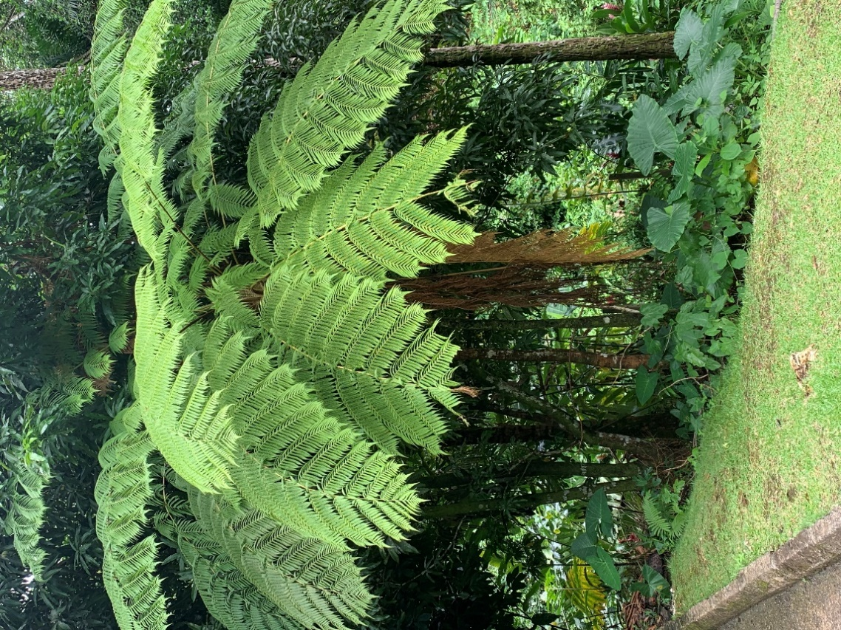 The Tree Fern

