Attention: All News Editors KINGSTON, Jamaica
(21 February 2025):

NEPA Supports MOHW to Tackle Air Pollution for Better Health

The National Environment and Planning Agency (NEPA) has reaffirmed its commitment to improving Jamaica’s air quality by partnering with the Ministry of Health & Wellness (MOHW) in integrating air quality considerations into national health programmes. This collaboration was highlighted at the recent workshop on Integrated Air Quality, Short-Lived Climate Pollutants, and Health Roadmap in Jamaica held at the Jamaica Pegasus Hotel from February 12-14, 2025.

Organized by the Pan American Health Organization/ World Health Organization (PAHO/WHO) in collaboration with the European Union (EU-CARIFORUM), MOHW, and NEPA, the workshop’s aims included: enhancing national capacities in assessing air pollution’s burden on health and supporting the development of an integrated roadmap addressing health, air pollution and climate change mitigation and adaptation strategies.

The workshop facilitated discussions on air pollution’s impact on public health, introduced participants to environmental epidemiology, and provided training on the WHO-developed AirQ+ tool, which estimates the health burden of air pollution. Additionally, stakeholders conducted a site visit to NEPA’s air quality monitoring station in the Cross Roads area to observe real-time air quality data collection.

NEPA Site Visit
During the opening session of the site visit, the Agency’s Chief Executive Officer and Government Town Planner, Mr. Leonard Francis, emphasized the agency’s role in air quality management through initiatives such as the Jamaica Air Quality Management Programme (JAQMP). He highlighted recent achievements, including the establishment of a local standard for PM2.5 in line with WHO guidelines and the expansion of the country’s ambient air quality monitoring network. PM2.5 is a measure for particulate matter (PM) that is 2.5 micrometres or less in diameter. The tiny particulate matter is fine enough to pose serious health risk as it can travel deep into the lungs when inhaled and enter into the blood stream.

“While NEPA has made significant strides in air quality management, there is still work to be done,” said Mr. Francis. “A critical gap remains in understanding the direct health impacts of air pollution. Through this partnership with MOHW and PAHO, we are committed to bridging that gap by integrating air quality data into national health monitoring systems.”

MOHW representatives underscored the importance of air quality in public health planning, particularly in relation to respiratory illnesses and other pollution-related diseases. The 3-day workshop sought to advance the EU-CARIFORUM project by gaining stakeholder support and strengthening national capacity in using AirQ+ to develop an integrated roadmap for air quality, short-lived climate pollutants, and health in Jamaica. The overall workshop supports Sustainable Development Goal indicators 3.9.1 and 11.6.2 which are focused on mortality rate from household and ambient air pollution, and national urban policies. The agency aims to pursue sustained partnerships with MOHW, PAHO/WHO, and other stakeholders to achieve the Vision 2030 goal of a healthy natural environment.

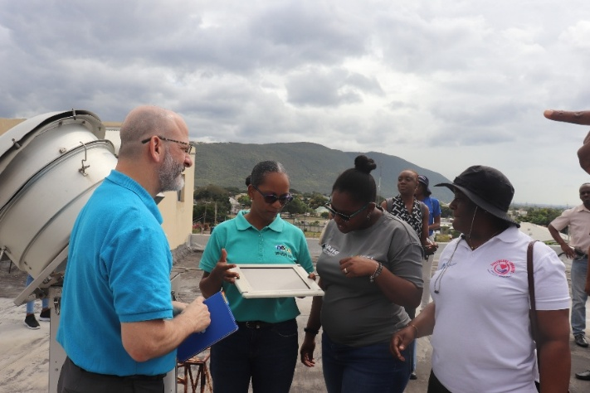
Photo 1: Jody-Ann Minott-Marston (middle), Manager, Air Quality Management Branch, NEPA demonstrating how particles are collected to Mr. Ian Stein (PAHO/ WHO), Melody Spence and Ann Kay Cunningham, MOHW

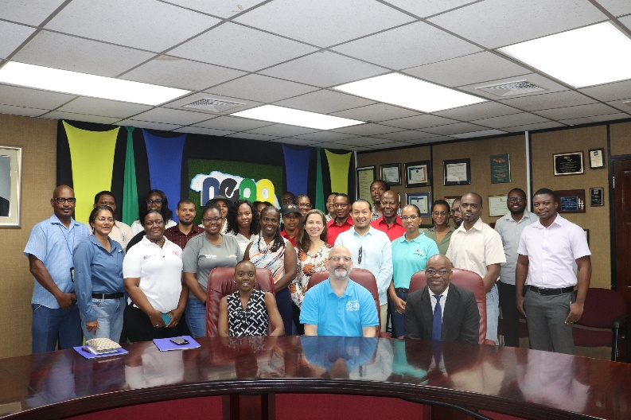
Photo 2: Representatives from PAHO/ WHO, MOHW, NEPA, Jamaica Bauxite Institute, Ministry of Labour & Social Security, Office of Disaster Preparedness and Emergency Management and academia pose for a photo op whilst on a tour to observe NEPA’s air quality monitoring facility.

-30-

For further information please contact:
Shahri Miller- Public Education and Corporate Communication Branch,
National Environment and Planning Agency.
Tel: 876-754-7540; ext. 2761
Email: shahri.miller@nepa.gov.jm ; Website: www.nepa.gov.jm

